DETECTION OF CREDIBILITY OF ONLINE MEDIA POSTS USING DEEP NEURAL NETWORK
A project report in partial fulfillment for the award of the degree of

MASTERS OF TECHNOLOGY
IN
COMPUTER SCIENCE AND SYSTEMS ENGINEERING

Submitted by

Ravi Ranjan Mallik
(316206415024)

Project Guide : Kaviti Prasad


DEPARTMENT OF COMPUTER SCIENCE AND SYSTEMS ENGINEERING ANDHRA UNIVERSITY COLLEGE OF ENGINEERING (A),
ANDHRA UNIVERSITY, VISAKHAPATNAM -530003

DECEMBER 2018
DEPARTMENT OF COMPUTER SCIENCE AND SYSTEMS ENGINEERING, ANDHRA UNIVERSITY COLLEGE OF ENGINEERING (A),
ANDHRA UNIVERSITY, VISAKHAPATNAM -530003



CERTIFICATE

This is to certify that the project titled “ Detection of Credibility of Online Media Posts Using Deep Neural Network ” is a certified record of work done by Mr. Ravi Ranjan Mallik (316206415024) students of M.Tech in the Department of Computer Science & Systems Engineering, Andhra University College of Engineering (A), Andhra University, Visakhapatnam during the period 2016-2018 in the partial fulfillment of the requirements for the award of M.Tech. This work has not been submitted to any other university for the award of Degree or Diploma.

Kaviti Prasad
Project Guide
Department of CS & SE,
Andhra University,

Prof. P. V. G. D. Prasad Reddy
Head of the Department
Department of CS & SE,
Andhra University,

DECLARATION

I hereby declare that the project entitled “ DETECTION OF CREDIBILITY OF ONLINE MEDIA POSTS USING DEEP NEURAL NETWORK ” is an original and authentic work done in the Department of Computer Science & Systems Engineering, Andhra University College of Engineering (A), Andhra University, Visakhapatnam, submitted in partial fulfillment of the requirements for the degree of Masters of Technology.

Ravi Ranjan Mallik
316206415024

--------------------------------
Signature

ACKOWLEDGEMENT

CONTENTS

Chapter Page No.

- Introduction
  - Introduction to Deep Learning
  - Practical Applications of Deep Learning
  - Word Embedding
  - Long Short-Term Memory
  - Introduction to Project
  - Scope of present study
  - Organization of project report

- Literature Survey

- Project Analysis
  - Problem Statement
  - Objectives
  - Existing system
  - Proposed system
  - System Specifications
    - Hardware Components
    - Software Components

- System Design & Methodology
  - System Architecture
  - Basic Component of System Architecture
  - Methodology
  - Project Model Layered Design
  - Project Flow Design

- Environment Step-up

- Implementation
  - Dataset Preprocessing
  - Input text Tokenizing
  - Word Embedding Tokenizing
  - Building and Compiling
  - Plotting the Result

- Result & Discussion

- Conclusion & Future Enhancement
  - Conclusion
  - Future Enhancement

- References

- Bibliography

Abstract

CHAPTER - 1
- INTRODUCTION

  - Introduction to Deep Learning

Deep Learning is an artificial intelligence function that imitates the workings of the human brain in processing data and creating patterns for use in decision making. Deep learning is a subset of machine learning in Artificial Intelligence (AI) that has networks capable of learning unsupervised from data that is unstructured or unlabeled.
Also known as Deep Neural Learning or Deep Neural Network.
Deep Learning has evolved hand-in-hand with the digital era, which has brought about an explosion of data in all forms and from every region of the world. This data, known simply as Big Data, is drawn from sources like social media, internet search engines, e-commerce platforms, online cinemas and more. This enormous amount of data is readily accessible and can be shared through fintech applications like cloud computing. However, the data, which normally is unstructured, is so vast that it could take decades for humans to comprehend it and extract relevant information. Companies realize the incredible potential that can result from unraveling this wealth of information, and are increasingly adapting to Artificial Intelligence (AI) systems for automated support.
One of the most common AI techniques used for processing Big Data is Machine Learning, a self-adaptive algorithm that gets increasingly better analysis and patterns with experience or with new added data. If a digital payments company wanted to detect the occurrence of or potential for fraud in its system, it could employ machine learning tools for this purpose. The computational algorithm built into a computer model will process all transactions happening on the digital platform, find patterns in the data set and point out any anomaly detected by the pattern.
Deep learning, a subset of machine learning, utilizes a hierarchical level of artificial neural networks to carry out the process of machine learning. The artificial neural networks are built like the human brain, with neuron nodes connected together like a web. While traditional programs build analysis with data in a linear way, the hierarchical function of deep learning systems enables machines to process data with a nonlinear approach. A traditional approach to detecting fraud or money laundering might rely on the amount of transaction that ensues, while a deep learning nonlinear technique would include time, geographic location, IP address, type of retailer and any other feature that is likely to point to a fraudulent activity. The first layer of the neural network processes a raw data input like the amount of the transaction and passes it on to the next layer as output. The second layer processes the previous layer’s information by including additional information like the user's IP address and passes on its result. The next layer takes the second layer’s information and includes raw data like geographic location and makes the machine’s pattern even better. This continues across all levels of the neuron network.
  - Practical Applications of Deep Learning
  - Word Embedding
  - Long Short-Term Memory
  - Introduction to Project
  - Scope of present study
  - Organization of project report
The project report is organized into seven chapters.

Chapter 1: INTRODUCTION

This chapter discusses brief description of Deep Learning, Word Embedding, Long Short-term Memory concept and their use in text processing. This chapter will focuses on the reason behind the proposed architecture of the Deep Neural Network model.

Chapter 2: LITERATURE SURVEY

Chapter 3: PROJECT ANALYSIS

This chapter deals with the motivation behind the problem and the problem statement. The current scenario is described in the existing system. Proposed system is discussed which is the main idea of the project. Objectives of the project are thoroughly analyzed.

Chapter 4: SYSTEM DESIGN & METHODOLOGY

In this chapter the proposed DNN model has been discussed. The Model architecture is constructed with different layers and is compiled before it’s trained. All the aspects involved in preprocessing, compiling and training has been over viewed.

Chapter 5: ENVIRONMENT SETUP

This chapter gives a detail description of all the requirements either software or hardware. It presents an evaluation of the input and output requirements, computer and storage requirements and communication requirements.

Chapter 6: IMPLEMENTATION

This chapter contains the code of various modules from retrieving training data and processing it to display the output of the proposed trained model on given input data.

Chapter 7: RESULTS AND DISCUSSIONS

This chapter evaluates the results obtained from the various training data and the outputs are discussed at each stage.

Chapter 8: CONCLUSIONS AND FUTURE ENHANCEMENTS

This chapter describes the final conclusions and evaluates if the project meets the desired objectives successfully. The chapter also explores the future enhancements that can be accomplished in order to modify the project and make it more accurate.

CHAPTER - 2

CHAPTER - 2

LITERATURE SURVEY

CHAPTER - 3

SYSTEM ANALYSIS

  - Problem Statement
The trends of sharing viral fake post, on the social media platform are increasing day by day, which is affecting the decision making capability of the user. There requires a system that provides the opportunity to verify the credibility of the post that are available on the social media platform.
This project aims to fulfill all those needs. As the existing systems are not completely based on artificial intelligence, the performance accuracy will remain unimproved although the dataset grows, in contrast to that, the proposed model performance will gradually increases with the increase in available dataset.

  - Objectives
This project aims to detect the posts over social media by predicting the credibility of the post and the source. The proposed work performs a simple posts detection method based on one of the artificial intelligence algorithms – Deep Neural Network. The deep model is designed in such a way that with the increase in the data set fed to the model, it will perform better every time.

  - Existing system
  - Proposed system
  - System Specifications
As the proposed work is the software system, it requires
    - Hardware Components
    - Software Components
.

2.4. System Specifications

The specifications of the system, used in the process of designing NMT Chatbot, are as follows:
Operating System: Windows 10

    - RAM : 8 GB

    - Hard Disk : 500GB

The software and hardware components that are used in the design of the project are as follows:

2.4.1. Software Components

- Python
- My SQL

2.4.2 . Hardware Components

- CPU

- GPU

- Motherboard

- Hard Drive

- Monitor

CHAPTER - 3
REQUIREMENT ANALYSIS

In this chapter, various requirements like software requirements, hardware requirements, special hardware and software required for training the data, storage requirements etc are mentioned.

3.1 Software Requirements
The software required to run the Chatbot are:
- Operating system (Windows, Linux or MacOS)
- Python 3+
- Related library packages like tensorflow, nmt, matplotlib, pandas etc

3.2 Hardware Requirements
The required hardware are:
- Computer system with basic input / output system (keyboard and display)
- 8GB RAM
- 500GB+ Hard Disk

3.3 Requirements for Training Data
Specific and more powerful software and hardware is required for training the data.
To train the data, one of the following options can be followed:
- Training data using CPU: It requires a powerful multicore processor.
- Training data using GPU: NVIDIA GPU is required along with CUDA
- Training data using cloud services: It requires access to Amazon Web Services or related cloud service provider

3.4 Storage Requirements
The data to be trained is obtained from the interent. The data size can be tens of Gigabytes. So, a database that can handle such huge amount of thata is required. Like MySQL database.

CHAPTER – 4
METHODOLOGY

.

In this chapter, there is discussion about the design and implementation of the AI chatbot.
First the general overview of the chatbot is discussed, then the implementation issues are discussed in the following part.

The proposed system needs following things.
- A model
- Training data
- Testing data
- Interface for chat

4.1 Model

A mathematical model of the chatbot was developed using Neural Machine Translation (NMT). The general model is provided by the tensorflow. This general model was taken and some modifications were done according to the needs of this project. The NMT model is based upon the Recurrent Neural Networks(RNN) and Long Short Term Memory(LSTM).

4.2 Training data

The training data was obtained from the data dump of the reddit website. The dump contains the comments and replies of thousands of users in JSON format. Data dump from one month was used in this project.
A typical comment from the source in JSON format.

{"author":"Arve","link_id":"t3_5yba3","score":0,"body":"Can we please deprecate the word \"Ajax\" now? \r\n\r\n(But yeah, this _is_ much nicer)","score_hidden":false,"author_flair_text":null,"gilded":0,"subreddit":"reddit.com","edited":false,"author_flair_css_class":null,"retrieved_on":1427426409,"name":"t1_c0299ap","created_utc":"1192450643","parent_id":"t1_c02999p","controversiality":0,"ups":0,"distinguished":null,"id":"c0299ap","subreddit_id":"t5_6","downs":0,"archived":true}

4.3 Testing data

The initial data can be divided into 2 parts. One part fot training and another for testing. The testing data was used to check the accuracy of the model while training.

4.4 Interface for chat

Interface is designed as console based that is users can chat with the AI chatbot through console or command prompt. The output is also displayed on the console.

The procedure for chatting with the chatbot works as follow:
- The user opens the chatbot application.
- A console appears asking for input.
- The user provides the input.
- The input is taken, the model analyzes the input and produces an output.
- The output is displayed in the console screen,
- The process repeats until application is closed by the user.

4.5 Design Implementation

The design is implemented using Python Programming language along with various libraries like

- Pandas : Pandas library is used to read and write the files.
- Tensorflow: Tensorflow is used to develop a model for the chatbot. The model is based upon the RNN, a specific type of Deep Learning Neural Network.
- NumPy : NumPy library is used so as to work with NumPy Arrays.
- Matplotlib : Matplotlib is used to visualize the output.

Apart from that the NMT module provided by the Google Tensorflow team is used as the underlying model of the chatbot.

The Diagram shows how LSTM is used to convert response to reply.

The below steps shows, how the project was done and implemented step by step:
- Collection of Relevant Data:
The relevant data was obtained from the data source. The data was obtained from reddit website data dump of comments. This data is open to all the people in the internet.

- Cleaning the Data:
The data obtained was in JSON format. It consisted of redundant data. Some data values were missing. Some responses didn’t have replies while few had multiple replies. Redundant and inconsistent data were removed. Responses with no replies were also removed. Responses having multiple replies were selected , however only the reply with maximum votes/score was selected. This clean data was fed into a database.

- Data transformation:
The data was then transformed to a desired format. Here, the desired format is a response-reply pair of comments. This data was then written back to flat text files. Responses were written to train.from file while their respective replies were written to train.to files. Some part of the data was separated as test data.

- Developing the model:
A deep learning model was developed for the chatbot. This was developed using the NMT module provided by the Tensorflow team. It was modified to suit the meets of this project.

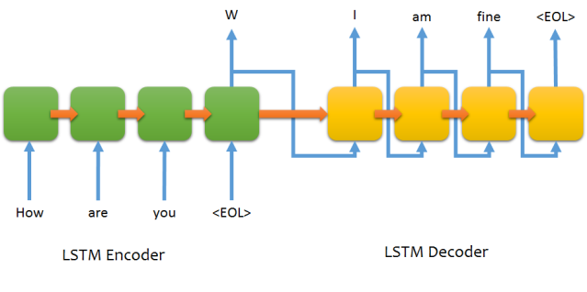

Fig:A Simple LSTM Network

- Training the model:
The model was then trained by feeding the training data into the model. Number of epochs was set to 5. A considerable amount of time (around 3 days) was required for complete training of the model.

- Testing the model:
After each epoch, the model was tested using test data and corresponding value of PPL(perplexity) was also noticed. The perplexity showed an overall decreasing trend with some sudden spikes at the middle.

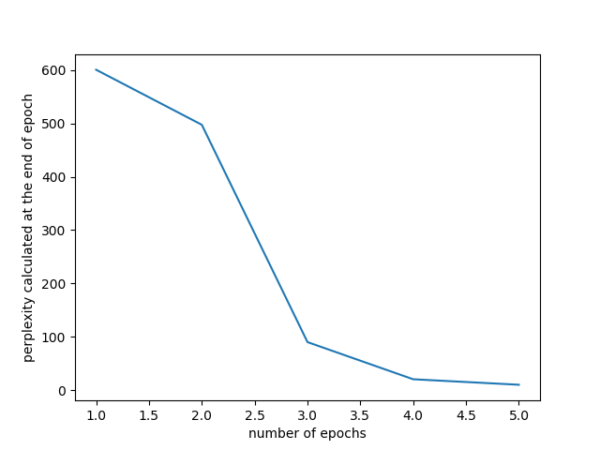
Fig:PPL vs number of epochs

- Developing Interface for chat
A user interface was developed using which user can chat with the AI chatbot.

CHAPTER – 5
CODING

5.1 Python Code for Parsing Data

import sqlite3
import json
from datetime import datetime
import time

timeframe = '2017-03'
sql_transaction = []
start_row = 0
cleanup = 1000000

connection = sqlite3.connect('{}.db'.format(timeframe))
c = connection.cursor()

def create_table():
c.execute("CREATE TABLE IF NOT EXISTS parent_reply(parent_id TEXT PRIMARY KEY, comment_id TEXT UNIQUE, parent TEXT, comment TEXT, subreddit TEXT, unix INT, score INT)")

def format_data(data):
data = data.replace('\n',' newlinechar ').replace('\r',' newlinechar ').replace('"',"'")
return data

def transaction_bldr(sql):
global sql_transaction
sql_transaction.append(sql)
if len(sql_transaction) > 1000:
c.execute('BEGIN TRANSACTION')
for s in sql_transaction:
try:
c.execute(s)
except:
pass
connection.commit()
sql_transaction = []

def sql_insert_replace_comment(commentid,parentid,parent,comment,subreddit,time,score):
try:
sql = """UPDATE parent_reply SET parent_id = ?, comment_id = ?, parent = ?, comment = ?, subreddit = ?, unix = ?, score = ? WHERE parent_id =?;""".format(parentid, commentid, parent, comment, subreddit, int(time), score, parentid)
transaction_bldr(sql)
except Exception as e:
print('s0 insertion',str(e))

def sql_insert_has_parent(commentid,parentid,parent,comment,subreddit,time,score):
try:
sql = """INSERT INTO parent_reply (parent_id, comment_id, parent, comment, subreddit, unix, score) VALUES ("{}","{}","{}","{}","{}",{},{});""".format(parentid, commentid, parent, comment, subreddit, int(time), score)
transaction_bldr(sql)
except Exception as e:
print('s0 insertion',str(e))

def sql_insert_no_parent(commentid,parentid,comment,subreddit,time,score):
try:
sql = """INSERT INTO parent_reply (parent_id, comment_id, comment, subreddit, unix, score) VALUES ("{}","{}","{}","{}",{},{});""".format(parentid, commentid, comment, subreddit, int(time), score)
transaction_bldr(sql)
except Exception as e:
print('s0 insertion',str(e))

def acceptable(data):
if len(data.split(' ')) > 1000 or len(data) < 1:
return False
elif len(data) > 32000:
return False
elif data == '[deleted]':
return False
elif data == '[removed]':
return False
else:
return True

def find_parent(pid):
try:
sql = "SELECT comment FROM parent_reply WHERE comment_id = '{}' LIMIT 1".format(pid)
c.execute(sql)
result = c.fetchone()
if result != None:
return result[0]
else: return False
except Exception as e:
#print(str(e))
return False

def find_existing_score(pid):
try:
sql = "SELECT score FROM parent_reply WHERE parent_id = '{}' LIMIT 1".format(pid)
c.execute(sql)
result = c.fetchone()
if result != None:
return result[0]
else: return False
except Exception as e:
#print(str(e))
return False

if __name__ == '__main__':
create_table()
row_counter = 0
paired_rows = 0

#with open('J:/chatdata/reddit_data/{}/RC_{}'.format(timeframe.split('-')[0],timeframe), buffering=1000) as f:
with open('/home/paperspace/reddit_comment_dumps/RC_{}'.format(timeframe), buffering=1000) as f:
for row in f:
#print(row)
#time.sleep(555)
row_counter += 1

if row_counter > start_row:
try:
row = json.loads(row)
parent_id = row['parent_id'].split('_')[1]
body = format_data(row['body'])
created_utc = row['created_utc']
score = row['score']

comment_id = row['id']

subreddit = row['subreddit']
parent_data = find_parent(parent_id)

existing_comment_score = find_existing_score(parent_id)
if existing_comment_score:
if score > existing_comment_score:
if acceptable(body):
sql_insert_replace_comment(comment_id,parent_id,parent_data,body,subreddit,created_utc,score)

else:
if acceptable(body):
if parent_data:
if score >= 2:
sql_insert_has_parent(comment_id,parent_id,parent_data,body,subreddit,created_utc,score)
paired_rows += 1
else:
sql_insert_no_parent(comment_id,parent_id,body,subreddit,created_utc,score)
except Exception as e:
print(str(e))

if row_counter % 100000 == 0:
print('Total Rows Read: {}, Paired Rows: {}, Time: {}'.format(row_counter, paired_rows, str(datetime.now())))

if row_counter > start_row:
if row_counter % cleanup == 0:
print("Cleanin up!")
sql = "DELETE FROM parent_reply WHERE parent IS NULL"
c.execute(sql)
connection.commit()
c.execute("VACUUM")
connection.commit()

5.2. Code for Training Data
import sys
import os
import argparse
from setup.settings import hparams
sys.path.append(os.path.realpath(os.path.dirname(__file__)))

sys.path.append(os.path.realpath(os.path.dirname(__file__)) + "/nmt")

from nmt import nmt
import tensorflow as tf

# Modified autorun from nmt.py (bottom of the file)

# We want to use original argument parser (for validation, etc)
nmt_parser =
argparse.ArgumentParser()
nmt.add_arguments(nmt_parser)

# But we have to hack settings from our config in there instead of commandline options

nmt.FLAGS, unparsed = nmt_parser.parse_known_args(['--'+k+'='+str(v)

for k,v in hparams.items()])

# And now we can run TF with modified arguments
tf.app.run(main=nmt.main, argv=[os.getcwd() + '\nmt\nmt\nmt.py'] + unparsed)

5.3 Python code for Inference

import sys
import os
sys.path.append(os.path.realpath(os.path.dirname(__file__)))
sys.path.append(os.path.realpath(os.path.dirname(__file__)) + "/nmt")
import argparse
from setup.settings import hparams, out_dir
from nmt import nmt
import tensorflow as tf
from core.tokenizer import tokenize, detokenize
from core.sentence import score_answers, replace_in_answers
import colorama

current_stdout = None

# That will not be as easy as training script, as code relies on input and output file in deep levels of code
# It also outputs massive amount of info

# We have to make own script for inference, so we could:cd ..
# - use it in interactive mode
# - import for use in other code

# - use input and output of our choice (so, for example, file as input and console as output,
# or even console as input and file as output (but why? ;) ), etc)

# Why that nmt module doesn't give us some easy to use interface?

# Start inference "engine"
def do_start_inference(out_dir, hparams):

# Silence all outputs
#os.environ['TF_CPP_MIN_LOG_LEVEL'] = '3'
global current_stdout
current_stdout = sys.stdout
sys.stdout = open(os.devnull, "w")

# Modified autorun from nmt.py (bottom of the file)
# We want to use original argument parser (for validation, etc)
nmt_parser = argparse.ArgumentParser()
nmt.add_arguments(nmt_parser)
# But we have to hack settings from our config in there instead of commandline options

flags, unparsed = nmt_parser.parse_known_args(['--'+k+'='+str(v) for k,v in hparams.items()])
# And now we can run TF with modified arguments
#tf.app.run(main=nmt.main, argv=[os.getcwd() + '\nmt\nmt\nmt.py'] + unparsed)

# Add output (model) folder to flags
flags.out_dir = out_dir

# Make hparams
hparams = nmt.create_hparams(flags)

## Train / Decode
if not tf.gfile.Exists(flags.out_dir):
nmt.utils.print_out("# Model folder (out_dir) doesn't exist")
sys.exit()

# Load hparams from model folder
hparams = nmt.create_or_load_hparams(flags.out_dir, hparams, flags.hparams_path, save_hparams=True)

# Choose checkpoint (provided with hparams or last one)
if not flags.ckpt:
flags.ckpt = tf.train.latest_checkpoint(flags.out_dir)

# Create model
if not hparams.attention:
model_creator = nmt.inference.nmt_model.Model
elif hparams.attention_architecture == "standard":
model_creator = nmt.inference.attention_model.AttentionModel
elif hparams.attention_architecture in ["gnmt", "gnmt_v2"]:
model_creator = nmt.inference.gnmt_model.GNMTModel
else:
raise ValueError("Unknown model architecture")
infer_model = nmt.inference.model_helper.create_infer_model(model_creator, hparams, None)

return (infer_model, flags, hparams)

# Inference
def do_inference(infer_data, infer_model, flags, hparams):

# Disable TF logs for a while
# Workaround for bug: https://github.com/tensorflow/tensorflow/issues/12414
# Already fixed, available in nightly builds, but not in stable version
# Maybe that will stay here to silence any outputs
os.environ['TF_CPP_MIN_LOG_LEVEL'] = '3'
global current_stdout
if not current_stdout:
current_stdout = sys.stdout
sys.stdout = open(os.devnull, "w")

# Spawn new session
with tf.Session(graph=infer_model.graph, config=nmt.utils.get_config_proto()) as sess:

# Load model
loaded_infer_model = nmt.inference.model_helper.load_model(infer_model.model, flags.ckpt, sess, "infer")

# Run model (translate)
sess.run(
infer_model.iterator.initializer,
feed_dict={
infer_model.src_placeholder: infer_data,
infer_model.batch_size_placeholder: hparams.infer_batch_size
})

# calculate number of translations to be returned
num_translations_per_input = max(min(hparams.num_translations_per_input, hparams.beam_width), 1)

answers = []
while True:
try:

nmt_outputs, _ = loaded_infer_model.decode(sess)

if hparams.beam_width == 0:
nmt_outputs = nmt.inference.nmt_model.np.expand_dims(nmt_outputs, 0)

batch_size = nmt_outputs.shape[1]

for sent_id in range(batch_size):

# Iterate through responses
translations = []
for beam_id in range(num_translations_per_input):

if hparams.eos: tgt_eos = hparams.eos.encode("utf-8")

# Select a sentence
output = nmt_outputs[beam_id][sent_id, :].tolist()

# If there is an eos symbol in outputs, cut them at that point
if tgt_eos and tgt_eos in output:
output = output[:output.index(tgt_eos)]
print(output)

# Format response
if hparams.subword_option == "bpe": # BPE
translation = nmt.utils.format_bpe_text(output)
elif hparams.subword_option == "spm": # SPM
translation = nmt.utils.format_spm_text(output)
else:
translation = nmt.utils.format_text(output)

# Add response to the list
translations.append(translation.decode('utf-8'))

answers.append(translations)

except tf.errors.OutOfRangeError:
print("end")
break

# bug workaround end
os.environ['TF_CPP_MIN_LOG_LEVEL'] = '0'
sys.stdout.close()
sys.stdout = current_stdout
current_stdout = None

return answers

# Fancy way to start everything on first inference() call
def start_inference(question):

global inference_helper, inference_object

# Start inference, set global tuple with model, flags and hparams
inference_object = do_start_inference(out_dir, hparams)

# First inference() call calls that method
# Now we have everything running, so replace inference() with actual function call
inference_helper = lambda question: do_inference(question, *inference_object)

# Rerun inference() call
return inference_helper(question)

# Model, flags and hparams
inference_object = None

# Function call helper (calls start_inference on first call, then do_inference)
inference_helper = start_inference

# Main inference function
def inference(questions, include_blacklisted = True):

# Process questions
answers_list = process_questions(questions, include_blacklisted)

# Return (one or more?)
if len(answers_list) ==
return answers_list[0]
else:
return answers_list

# Internal inference function (for direct call)
def inference_internal(questions):

# Process questions and return
return process_questions(questions)

# Get index and score for best answer
def get_best_score(answers_score, include_blacklisted = True):

try:
index = answers_score.index(1)
score = 1
except:
index = None

if index is None and include_blacklisted:
try:
index = answers_score.index(0)
score = 0
except:
index = 0
score = -1

if index is None:
index = 0
score = -1

return (index, score)

# Process question or list of questions
def process_questions(questions, include_blacklisted = True):

# Make a list
if not isinstance(questions, list):
questions = [questions]

# Clean and tokenize
prepared_questions = []
for question in questions:
question = question.strip()
prepared_questions.append(tokenize(question) if question else '##emptyquestion##')

# Run inference
answers_list = inference_helper(prepared_questions)

# Process answers
prepared_answers_list = []
for index, answers in enumerate(answers_list):
answers = detokenize(answers)
answers = replace_in_answers(answers, 'answers')
answers_score = score_answers(answers, 'answers')
best_index, best_score = get_best_score(answers_score, include_blacklisted)

if prepared_questions[index] == '##emptyquestion##':
prepared_answers_list.append(None)
else:
prepared_answers_list.append({'answers': answers, 'scores': answers_score, 'best_index': best_index, 'best_score': best_score})

return prepared_answers_list

# interactive mode
if __name__ == "__main__":

# Input file
if sys.stdin.isatty() == False:

# Process questions
answers_list = process_questions(sys.stdin.readlines())

# Print answers
for answers in answers_list:
print(answers['answers'][answers['best_index']])

sys.exit()

# Interactive mode
print("\n\nStarting interactive mode (first response will take a while):")
colorama.init()

# QAs
while True:
question = input("\n> ")
answers = process_questions(question)[0]
if answers is None:
print(colorama.Fore.RED + "! Question can't be empty")
else:
for i, _ in enumerate(answers['scores']):
print("{}- {}{}".format(colorama.Fore.GREEN if answers['scores'][i] == 1 else colorama.Fore.YELLOW if answers['scores'][i] == 0 else colorama.Fore.RED, answers['answers'][i], colorama.Fore.RESET))

CHAPTER – 6
RESULTS AND DISCUSSIONS

6.1 Data being trained

Discussion
Figure 6.1 Data being trained as shown in anaconda prompt

The data from various sources is collected and training is carried out .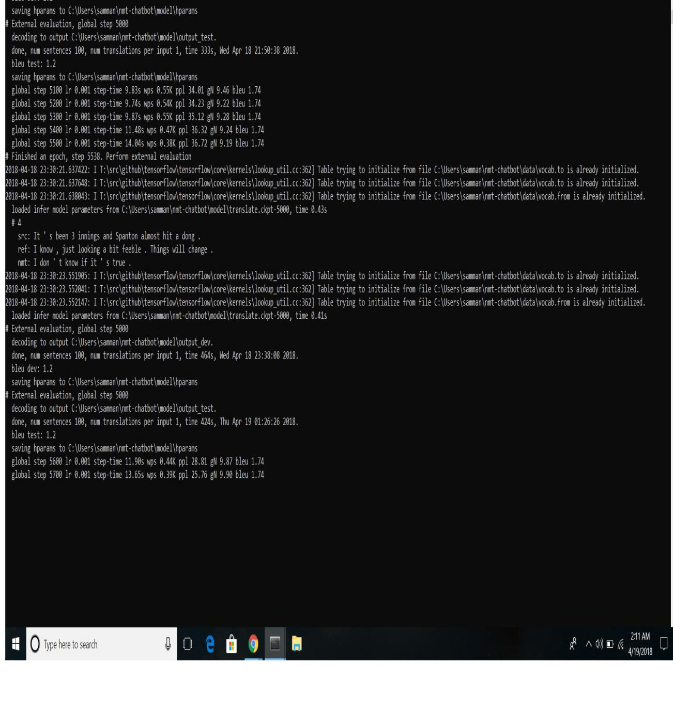

6.2 Output Desired

Discussion:

The output is shown as follows.The first line shows the input from the user and succeeding lines are the replies from the chatbot .Each reply is assigned a score .The following diagrams show the instances of conversation with the chatbot.
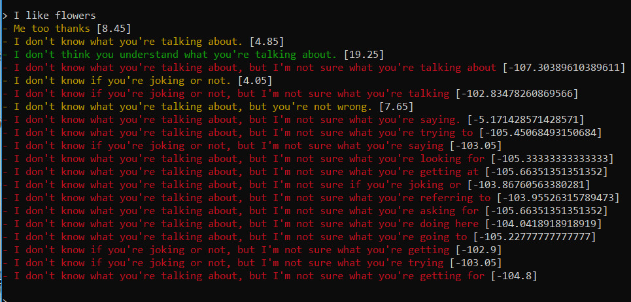
Figure:1
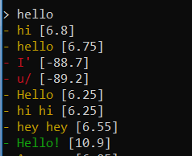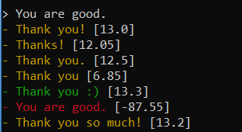
Figure:2

CHAPTER – 7
CONCLUSION AND FUTURE ENHACEMENT

7.1. Conclusion

In this project, the comments dump from the reddit website is downloaded which is in JSON format. It is then converted into python object format which is then stored to database. The comments are stored in comment-reply pair in the database. Then it is copied back to flat files. Comments are stored in train.from file. Their corresponding resoponses are stored in train.to file. These files serve as training data. A NMT model based upon Recurrent Neural Networks(RNN) is used to fit the training data. After multiple epochs, the model became able to take comments from the user and provide relevant responses. The accuracy of the model is tested using various input comments. The responses from the chatbot is also analyzed. The chatbot became fairly decent on providing relevant output to the input comments. However, it also suffered from the drawbacks of having less vocabulary. However, the accuracy can be easily improved by using more training data.

7.2. Future Enhancement

The chatbot can be made more responsive and more accurate by training the above model with more amount of training data. For this, high speed GPU is required. Alternatively, premium services from AWS(Amazon Web Services) can be used to fit the data in short amount of time. In future, stronger GPUs will be available in cheaper prices. Hence, more data can be trained in short amount of time. This will make the chatbot more accurate.

REFERENCES:
[1] R. S. Russell, “Language Use, Personality and True Conversational Interfaces”, Project Report of AI and CSUniversity of Edinburgh, Edinburgh, pp.1-80, 2002.

[2] Y. Zhou, X. Ziyu, A. W. Black, A. I. Rudnicky, “Chatbot Evaluation and Database Expansion via Crowdsourcing”, Proc. of the Chatbot Workshop of LREC, US, pp. 16-19, 2016.
[3] C. R. Anik, C. Jacob, A. Mohanan, “A Survey on Web Based Conversational Bot Design”, JETIR, Vol.3, Issue.10, pp. 96-99, 2016.

[4] R. P. Schumaker, H. Chen, “Leveraging Question Answer Technology to Address Terrorism Inquiry”, Decision Support Systems, Vol.4, Issue.3, pp. 1419-1430, 2007.

[5] B. P. Kiptonui, “Chatbot Technology: A Possible Means of Unlocking Student Potential to Learn How to Learn, Educational Research”, Vol.4, Issue.2, pp. 218-221, 2013.

[6] S. Ghose, J. J. Barua, “Toward the Implementation of a Topic Specific Dialogue Based Natural Language Chatbot as an Undergraduate Advisor”, International Conference on Informatics, Electronics & Vision, India, pp. 1-5, 2013.

[7] J. Jia, “the The Study of the Application of a Keywords-based Chatbot System on Teaching of Foreign Languages”, Report of University of Augsburg, Augsburg, , pp.1-36, 2003.

BIBILOGRAPHY

1.https://thesai.org/Downloads/Volume6No7/Paper_12-Survey_on_Chatbot_Design_Techniques_in_Speech_Conversation_Systems.pdf

2. https://www.chatbots.org. (2016). Chatbot. [online] Available at: https://www.chatbots.org/chatbot/

3. https://chatbotsmagazine.com/do-you-want-your-chatbot-converse-in-foreign-languages-my-learnings-from-bot-devs-9b608f685f5b

4. https://www.analyticsvidhya.com/blog/2018/01/faq-chatbots-the-future-of-information-searching/

5. https://blog.chatteron.io/chat-bots-in-human-resource-90e61c55f2b

